DBMS – LAB -04

**NAME** : RAHUL VARMA

**ROLL NO**: S20200010212

**SECTION**: C

**TASK:** (LAB EXERCISES)

SQL COMMANDS

1. GROUP BY CLAUSE

2. ORDER BY CLAUSE

**EXERCISE 1:**

CREATING TABLE

AND LOADING DATA FROM GIVEN DATA BY USING MYSQL WORK BENCH

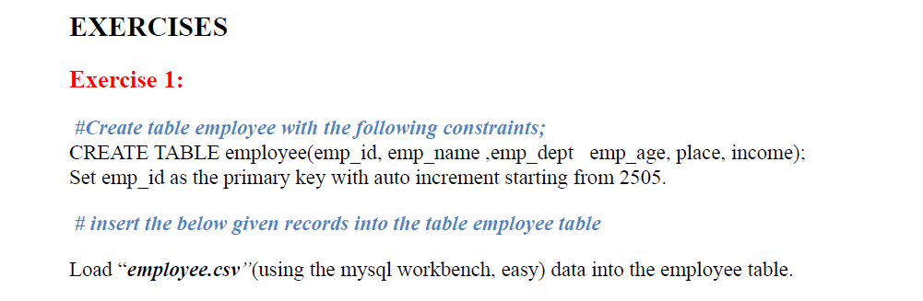

**QUESTION :**

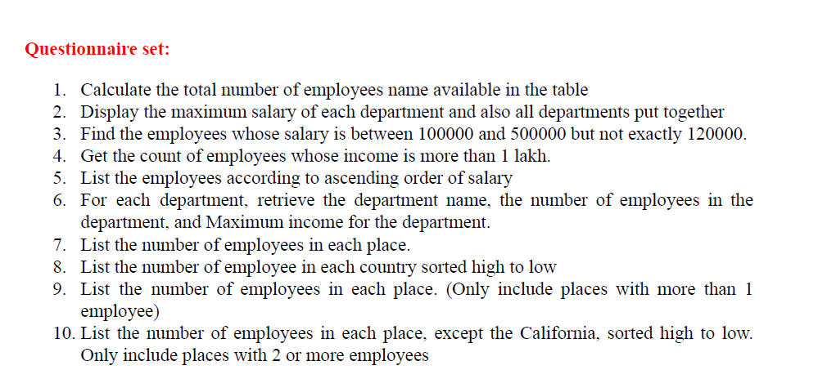

MYSQL COMMAND PROMPT SCREEN SHOTS:

TABLE CONTENT :

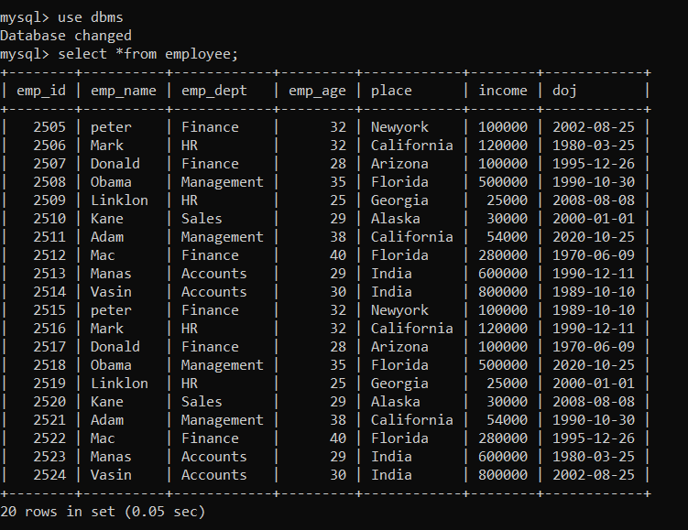

1.

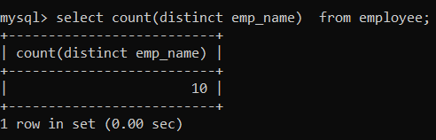

2.

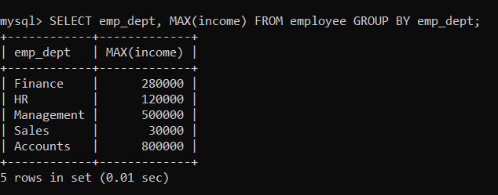

3.

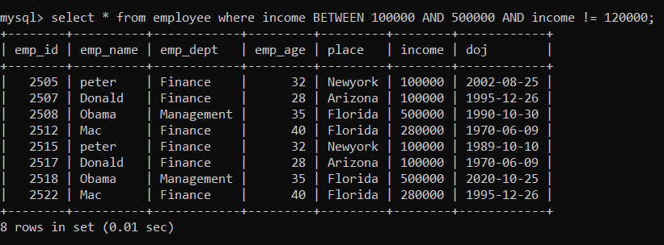

4.

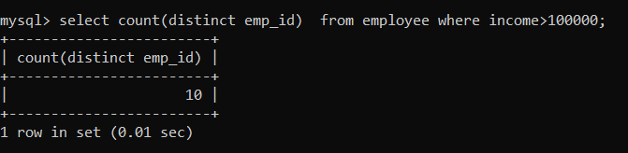

5.

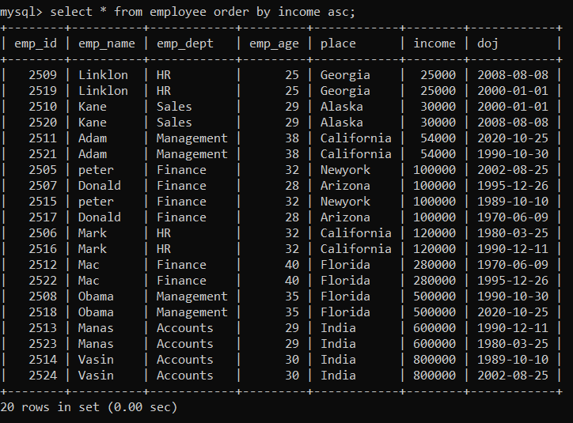

6.

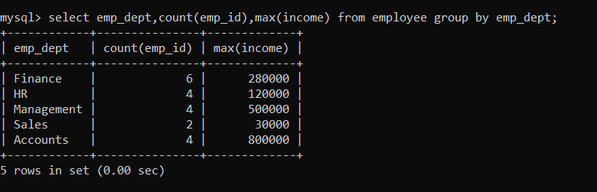

7.

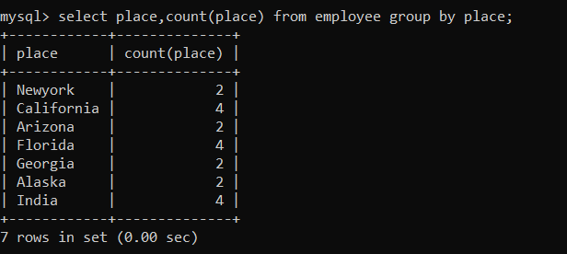

8.

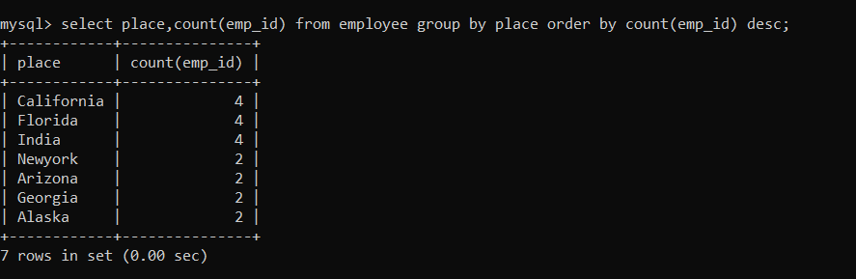

9.

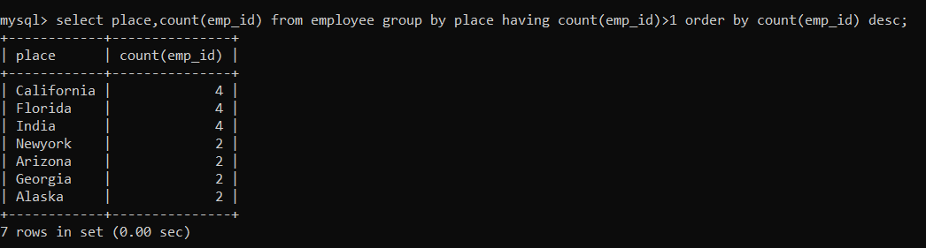

10.

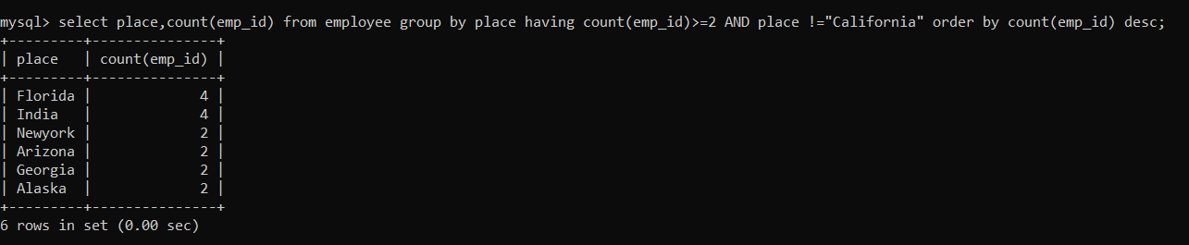

**EXERCISE 2:**

**QUESTIONS :**

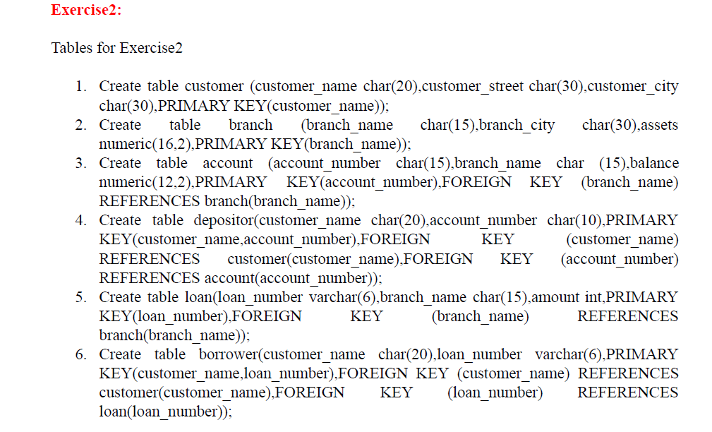

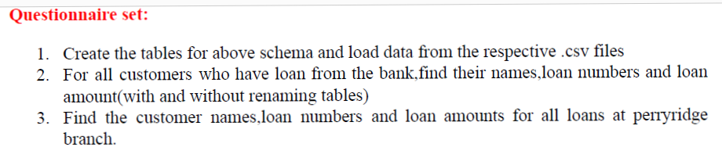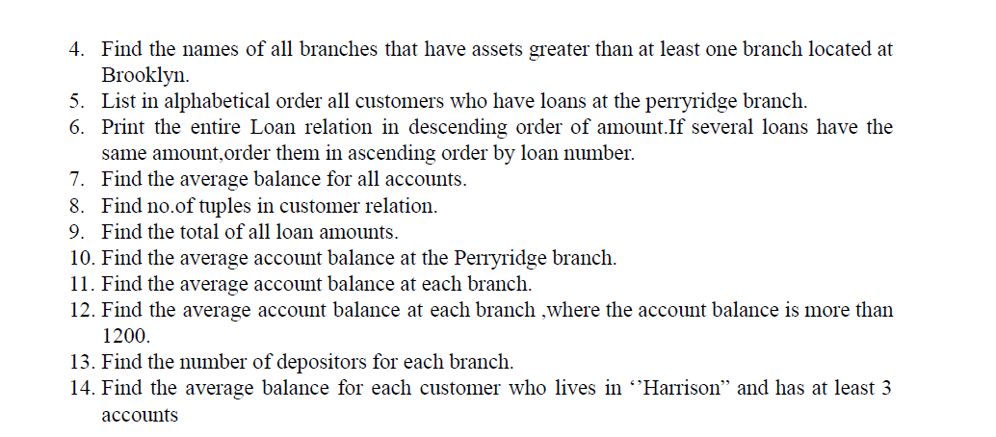

**EXERCISE 2:**

**CREATE TABLE employee(emp_id int, emp_name varchar(20), emp_dept varchar(20),emp_age int, place varchar(20), income int, doj date);**

**ALTER TABLE employee auto_increment=2505;**

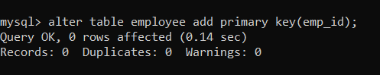

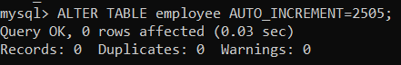

1.

**ACCOUNT TABLE:**

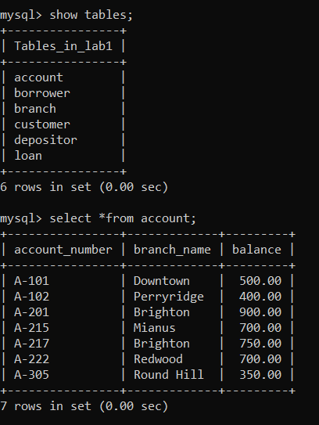

**BORROWER TABLE:**

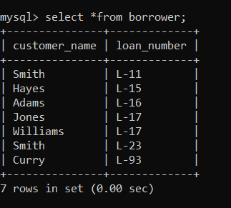

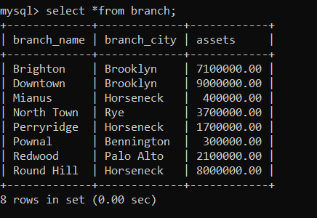 **(BRANCH TABLE )**

**CUSTOMER TABLE**:

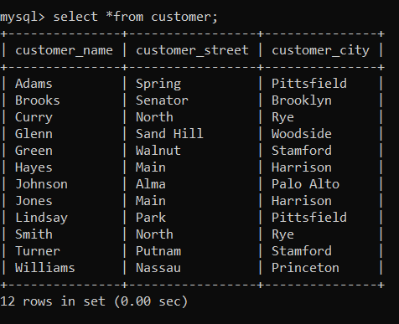

**DEPOSITER TABLE:**

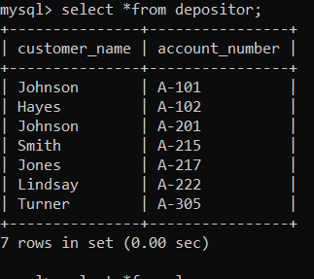

**LOAN TABLE:**

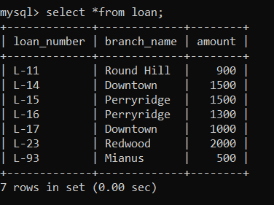

2.

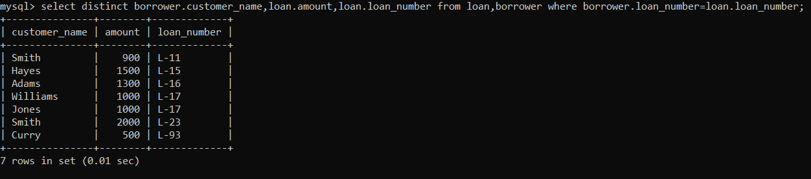

3.

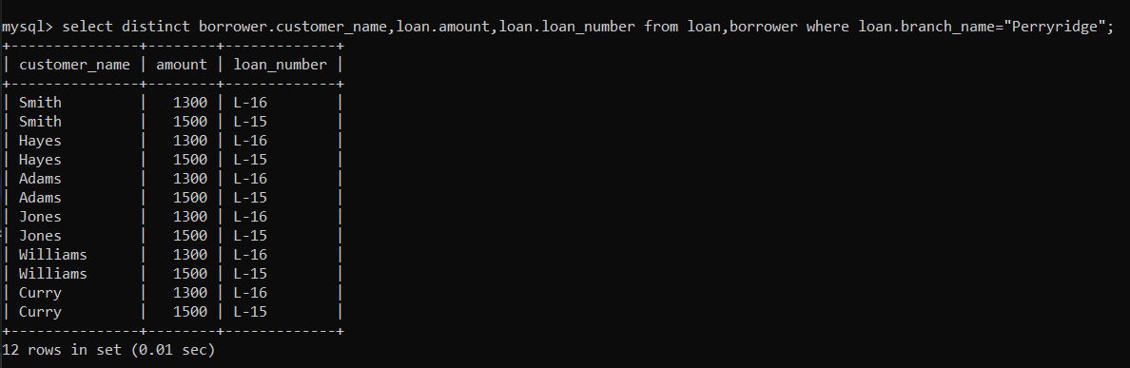

4.

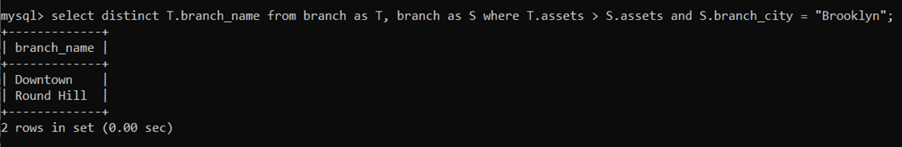

5.

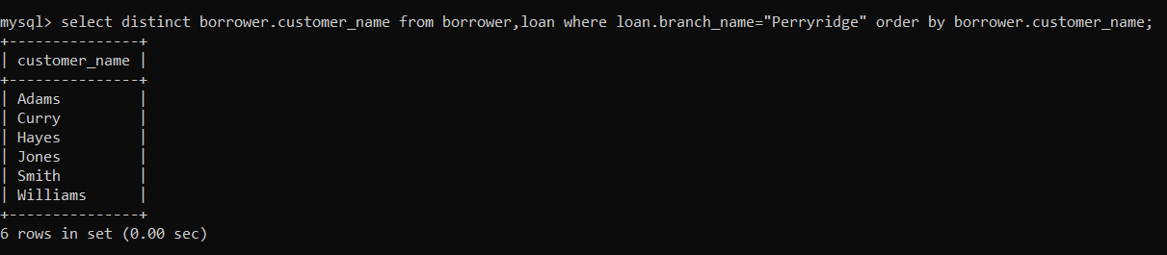

6.

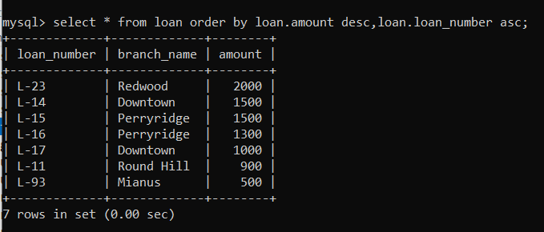

7.

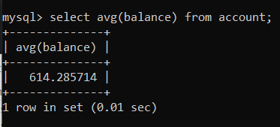

8.

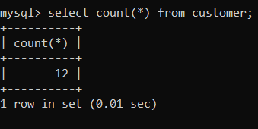

9.

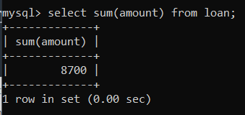

10.

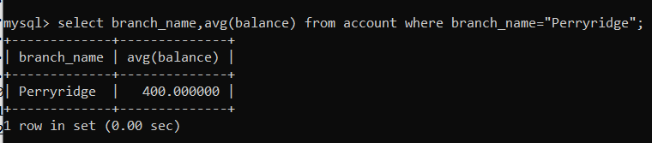

11.

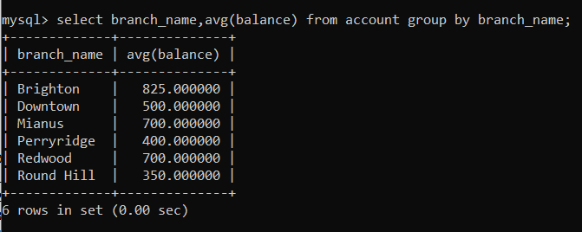

12.



13.

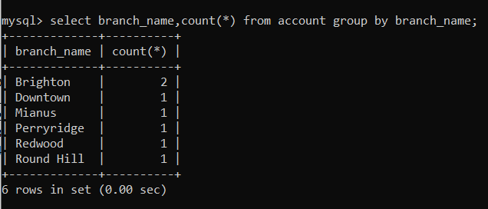

14.

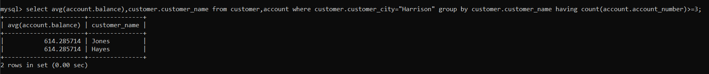

THANK YOU